**Game Design Document for:**

*Breaking Greg*

All work Copyright ©2018

Written by Team AIE Production

Table of Contents

**1.0 Revision History** **3**

**2.0 Game Overview** **4**

2.1 High Concept 4

2.2 Synopsis 4

2.3 Pillars 4

2.4 Genre 4

2.5 Target Demographic 4

**3.0 Mechanics** **4**

3.1 Movement 5

3.2 Combat 5

3.2 Combo 5

3.3 Win lose state 5

3.4 Score 6

3.5 Environment Interaction 6

3.6 Rage 6

3.7 Thrown object 6

3.8 Enemies 6

**4.0 Items** **7**

**5.0 Game Flow** **7**

5.1 ‘Mission’ / ‘Level’ structure 7

5.2 Objectives 7

5.2.1 Optional objectives 8

**6.0 Story and Characters** **8**

6.1 Characters 9

6.2 Storyline 9

**7.0 Levels** **9**

7.1 Level X 9

7.1.1 Features 9

7.1.2 Aesthetic/setting 9

**8.0 Interface** **10**

8.1 GUI Elements 11

8.1.1 HUD 11

8.1.2 Menus 13

8.2 Camera 14

8.3 Controls 14

**9.0 Art Style and Aesthetic** **16**

9.1 References 16

9.2 Lighting 16

9.3 Pipeline 16

**10.0 Release Details** **16**

10.1 Editor/Engine 16

10.2 Platforms 16

10.3 Business Model 16

**11.0 Sound** **16**

11.1 Music 16

11.2 SFX list 17

# 1.0 Revision History

| Version | Description |
| --- | --- |
| 1.0 | Initial document |

# 2.0 Game Overview

## 2.1 High Concept

Isometric office set hack & Slash. Physics based combat causing Environmental destruction & High impact violence. Cause destruction across the level in an attempt to cause maximum collateral damage for HR to deal with.

## 2.2 Synopsis

USPs

* Fluid combat system
* Score
* Repeatable levels
* Special abilities
* Theme (corporate oppression, 1984, 9-5, propaganda)

## 2.3 Pillars

* Satisfying Player Feedback
* Ironic Premic
* Fast Paced Combat

## 2.4 Genre

Hack and Slash genre which will be used to emphasize the combat with melee based weapons (fists). Will also feature projectile based weapons (intractable throwable props). The camera will be from an isometric view point which is representing 3 dimensional assets in a 2 dimensional space

## 2.5 Target Demographic

15+ ( High cartoon violence )

Any Gender

Casual gamer

Highly replayable experience from random level generation

Competitive elements from score system

# 3.0 Mechanics

## 3.1 Movement

*360 Degree Run*

*Idle state*

## 3.2 Combat

*Light Attack (Punch)*

*Basic punch attack hitting all enemies in front of the player at a moderately fast speed*

*Heavy Attack (Slam)*

*AOE damage all around the player rather than in a particular direction*

*Stuns large enemies to open them up to take damage*

*Combo*

*Consecutive landed hits on both people*

*Combo breaks when the player is hit or misses an attack*

*Throwables*

*Medium objects can be picked up and thrown to deal damage to enemies*

*Break on impact*

*Refer to 3.7*

## 3.2 Combo

* + - 1. No effect on Combat
      2. Is basically a score modifier system

is increased by constantly killing people

if the player has not killed someone in x seconds combo modifier is reset to 0

more of a player feedback system

Example:

x5 combo is +5% score of initial value

x37 combo is +37% of initial value

if a office worker initial value is 100 score

at x35 combo their new value is 135 points

## 3.3 Win lose state

*Win - getting to the next level*

*Lose - police getting called, rage meter getting to 0*

## 3.4 Score

* + 1. Final Score is calculated at a lose state

*Gain score through destroying objects & killing people which is increased through the combo*

*Level & Destroyed objects & Kills*

*Time spent in a level depreciates total level score (longer player spends less score is gained from level*

*Gain incremental score bonus through going up a level*

## 3.5 Environment Interaction

Destructible Objects

Large objects break into pieces after being hit

Vending Machines

Players can interact with vending machines to get a brief speed boost

Vending machines are one use and break after one use

Throwables

Medium sized objects can be picked up and thrown and break on impact

## 3.6 Rage

Rage runs down overtime during gameplay but goes up when the player kills NPCs

When rage is empty the player loses

When rage is full the player can press space to activate chaos mode

During chaos mode time slows but the player stays at normal speed

Rage stays full during chaos

After chaos runs out rage is half full

## 3.7 Thrown object

Lifetime on throwables to always break after a distance

Differs object to object

Object travel through enemies for collaterals

Different objects have different sized hit boxes for AOE

## 3.8 Enemies

Genetic : Running away to to random point

Running to hide

Running to telephone (specific meshes as identifying them as important)

Requires 1 hit to kill

ffInitial score value: 100

Beefy guys:

Running towards the player

Require a Stun to be damaged

(Throwing an object at them, or special ability)

Require 3 hits to kill

each hit adds to combo

Initial score value: 300

# 4.0 Items

| Item | Throwable | Breakable | Physics | Effects |
| --- | --- | --- | --- | --- |
| *Medium Object* | Yes | Not Until Thrown | Yes | Deals Damage |
| *Vending machine* | No | After being interacted with | No | Speed Boost |

# 5.0 Game Flow

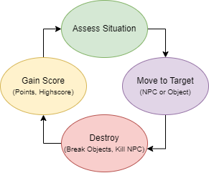

## 5.1 ‘Mission’ / ‘Level’ structure

*Level to level progression with the player going floor to floor gaining as much score as possible as quickly as possible. Each floor will be progressing with rising difficulty.*

## 5.2 Objectives

*Objectives:*

*Stopping NPC’s from getting to telephones*

*NPC’s call police to subdue greg*

*This causes a timer to begin counting down*

*telephone have countdown until phone call is made allowing player to stop them*

*Causing as much monetary damage to the company as possible*

*Each object has a cost value which is added to a score counter*

*Getting to as high a floor as possible*

*Keeping rage bar up so you don’t lose*

## 5.2.1 Optional objectives

*Optional objectives include finding the hidden easter eggs and fun additions found within levels.*

# 6.0 Story and Characters

## 6.1 Characters

*Greg is a simplistic regular office worker living a depressing life which seems to have fallen apart and thrown him off the rails.*

## 6.2 Storyline

*Gregs (Main Characters) life has gone off the rails with everything seemingly falling apart and now he has gone off his medication and is performing a blind rage on his office building going floor to floor murdering all of is co workers and trying to cause as much company damage as possible.*

# 7.0 Levels

## 7.1 Level X

*50 levels are designed and created then randomly picked from a list for the and as the player progresses levels rise in difficulty.*

*We want nobody to make it past level 50. This is a goal as there will only be 5 milestones (eg 1-10) but the game is still endless so if anyone makes it past they can continue.*

### 7.1.1 Features

*Telephones are spawned in special rooms within the level, which allow NPCs to Call the authorities on greg, causing the loose state.*

*Milestone Difficulty changes (Changes every 10 rounds)*

*Amount of hits to kill stunable enemies (3 to 4 eg)*

*Visuals of stunning enemies*

*Ramping difficulty (Changes every round)*

*NPC movement speed*

*Stun duration*

*Amount of telephone NPCs*

*Amount of buff guy NPCs*

### 7.1.2 Aesthetic/setting

*1990’s drab office setting*

*backrooms*

*corporate beige walls*

# 8.0 Interface

|  |
| --- |
| Main Menu flowchart |

## 8.1 GUI Elements

### 8.1.1 HUD

| *w* |
| --- |
| *Rage Meter* |
|  |
| *Combo Multiplier* |
|  |
| *Phone alert Icon* |
|  |
| *Score ($ damage caused)* |
|  |
| *Highscore* |

### 8.1.2 Menus

*Menu (With diegetic objects)*

Start: When clicked will load game level.

Controls: Will open a page with an image of control scheme.

Exit: Will close game.

*Pause Menu*

Resume: Will unpause the game.

Controls: Will open a page with an image of control scheme.

Exit to main menu: Will leave the level and will open main menu.

## 8.2 Camera

Isometric



## 8.3 Controls

*Keyboard*

*Menu:* ***Esc***

*Menu Navagate:* ***Mouse***

*Light Attack/Throw:* ***LMB***

*AOE Attack:* ***RMB***

*Move/look:* ***WASD***

*Activate Rage:* ***Spacebar***

*Interact/Pickup:* ***E***

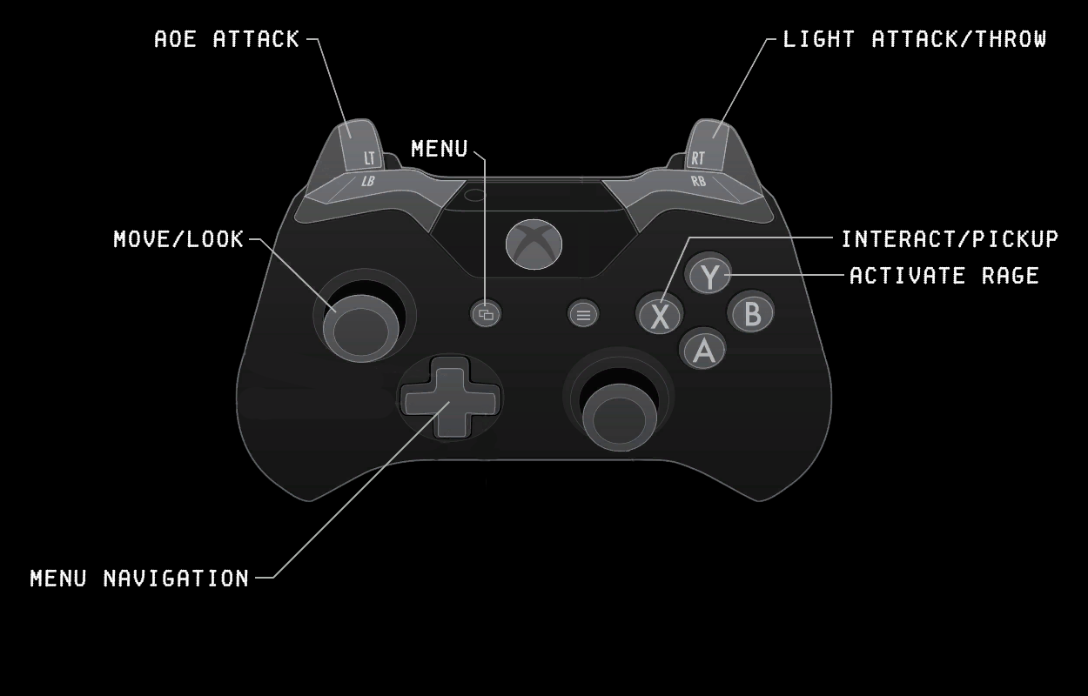

*Controller*

*Menu:* ***View button***

*Menu Navagate:* ***D-pad/Right stick***

*Light Attack/Throw:* ***RT***

*AOE Attack:* ***LT***

*Move/look:* ***Left stick***

*Activate Rage:* ***Y***

*Interact/Pickup:* ***X***

# 9.0 Art Style and Aesthetic

*Refer to the Art Style Guide*

## 9.1 References

*Refer to ArtBible*

## 9.2 Lighting

*Refer to ArtBible*

## 9.3 Pipeline

*Refer to ArtBible*

# 10.0 Release Details

## 10.1 Editor/Engine

*Unity*

## 10.2 Platforms

*PC*

## 10.3 Business Model

*One Time purchase*

# 11.0 Sound

## 11.1 Music

| *Name:* | *Use:* | *Reference:* |
| --- | --- | --- |
| Elevator music 1 | When the player first enters a room and has not caused any chaos. | <https://www.youtube.com/watch?v=xy_NKN75Jhw&ab_channel=GamingSoundFX> |
| Elevator music 2 | Plays during Loading screen. | <https://www.youtube.com/watch?v=VBlFHuCzPgY&ab_channel=AntoineB> |
| Office ambience & Elevator music 1 | Used for Main Menu | <https://www.youtube.com/watch?v=I0qpNCg4rMo&t=24s&ab_channel=AmbienceHub>  <https://www.youtube.com/watch?v=xy_NKN75Jhw&ab_channel=GamingSoundFX> |

## 11.2 SFX list

| *Name:* | *Use:* | *Reference:* |
| --- | --- | --- |
| Walk | NPC and Aggressive NPC | <https://www.youtube.com/watch?v=SBKUv4YqrG4&ab_channel=HQSounds> |
| Run | Player, NPC and Aggressive NPC | <https://www.youtube.com/watch?v=85MlyOJUnag&ab_channel=HQSounds> |
| Punch impact | Player and Aggressive NPC. | <https://www.youtube.com/watch?v=OFN2yOLuqB0&ab_channel=PlaySounds> |
| Punch Swing | Player and Aggressive NPC. | <https://www.youtube.com/watch?v=3Gda_f9BsXI&ab_channel=TheMathewFlames> |
| Breaking sounds for medium objects | When objects are interacted and break. | <https://www.soundsnap.com/user/6460857/favorites/274660> |
| Phone Ring | When NPC uses the phone. | <https://www.soundsnap.com/phone_standard_ring_x2> |
| NPC Grunts/Screen | When an NPC takes damage. | <https://www.soundsnap.com/male3_hurt2> |
| NPC Dialog | When an NPC takes damage. | <https://www.soundsnap.com/male_voice_yelling_stop_and_crying> |
| Phone interrupt | When the player kills NPC before cops are called. | <https://www.soundsnap.com/mobile_phone_key_tone_off>  <https://www.soundsnap.com/emergency_police_dispatch_radio_int_car_adult_male_disregard_the_call_01> |
| Police call timer ends | When the NPC finishes calling the cops. | <https://www.soundsnap.com/interior_car_police_radio_dispatch_young_man_says_transport_is_on_the_way_blastwavefx_11218> |